Exp No. | Input |  |  |  |  | Output or parameter to be predicted
 | Pulse On Time (Âµs) | Pulse Off Time (Âµs) | Servo Voltage (V) | Applied Current (A) | Angle of wire | Surface Undulation (Âµm) | Substance Vaporization Rate  (mm3/min) | Kerf Clearence(mm)
1 | 12 | 12 | 55 | 4 | 60 | 4.137 | 5.866 | 1.378
2 | 12 | 12 | 60 | 3.5 | 60 | 3.752 | 5.556 | 1.277
3 | 8 | 14 | 70 | 5 | 30 | 2.458 | 4.770 | 0.943
4 | 8 | 14 | 50 | 5 | 90 | 3.795 | 5.695 | 1.289
5 | 12 | 12 | 55 | 4 | 60 | 4.225 | 5.957 | 1.400
6 | 12 | 12 | 60 | 3.5 | 60 | 3.782 | 5.653 | 1.286
7 | 8 | 10 | 70 | 5 | 90 | 2.692 | 4.919 | 1.004
8 | 8 | 14 | 70 | 5 | 30 | 2.542 | 4.838 | 0.965
9 | 12 | 13 | 60 | 4 | 60 | 3.561 | 5.442 | 1.227
10 | 8 | 14 | 50 | 5 | 90 | 3.885 | 5.773 | 1.311
11 | 16 | 10 | 70 | 5 | 30 | 3.431 | 5.540 | 1.194
12 | 16 | 10 | 70 | 3 | 90 | 3.195 | 5.021 | 1.135
13 | 8 | 10 | 70 | 5 | 90 | 2.777 | 5.024 | 1.026
14 | 12 | 13 | 60 | 4 | 60 | 3.645 | 5.535 | 1.249
15 | 16 | 10 | 70 | 5 | 30 | 3.529 | 5.643 | 1.219
16 | 16 | 10 | 70 | 3 | 90 | 3.279 | 5.172 | 1.155
17 | 12 | 12 | 60 | 4.5 | 60 | 3.859 | 5.736 | 1.305
18 | 12 | 12 | 60 | 4.5 | 60 | 3.774 | 5.644 | 1.283
19 | 16 | 14 | 50 | 3 | 90 | 4.577 | 5.901 | 1.489
20 | 16 | 14 | 50 | 3 | 90 | 4.487 | 5.797 | 1.467
21 | 8 | 14 | 70 | 3 | 90 | 2.209 | 4.290 | 0.879
22 | 8 | 14 | 70 | 3 | 90 | 2.285 | 4.393 | 0.898
23 | 14 | 12 | 60 | 4 | 60 | 4.026 | 5.785 | 1.347
24 | 14 | 12 | 60 | 4 | 60 | 3.937 | 5.683 | 1.325
25 | 12 | 12 | 65 | 4 | 60 | 3.331 | 5.338 | 1.169
26 | 12 | 12 | 65 | 4 | 60 | 3.415 | 5.440 | 1.191
27 | 8 | 10 | 50 | 3 | 30 | 4.829 | 6.589 | 1.556
28 | 12 | 12 | 60 | 4 | 75 | 3.638 | 5.517 | 1.249
29 | 12 | 11 | 60 | 4 | 60 | 3.925 | 5.752 | 1.322
30 | 8 | 10 | 50 | 3 | 30 | 4.910 | 6.668 | 1.576
31 | 12 | 12 | 60 | 4 | 75 | 3.725 | 5.620 | 1.272
32 | 12 | 11 | 60 | 4 | 60 | 4.017 | 5.850 | 1.347
33 | 16 | 10 | 50 | 5 | 90 | 5.060 | 6.577 | 1.615
34 | 16 | 10 | 50 | 5 | 90 | 4.944 | 6.467 | 1.584
35 | 16 | 14 | 70 | 3 | 30 | 2.963 | 4.848 | 1.074
36 | 16 | 14 | 70 | 3 | 30 | 3.042 | 4.950 | 1.093
37 | 16 | 14 | 50 | 5 | 30 | 4.722 | 6.258 | 1.528
38 | 16 | 14 | 50 | 5 | 30 | 4.812 | 6.331 | 1.551
39 | 12 | 12 | 60 | 4 | 45 | 3.895 | 5.773 | 1.314
40 | 12 | 12 | 60 | 4 | 45 | 3.808 | 5.684 | 1.291
41 | 10 | 12 | 60 | 4 | 60 | 3.531 | 5.519 | 1.222
42 | 10 | 12 | 60 | 4 | 60 | 3.612 | 5.614 | 1.241

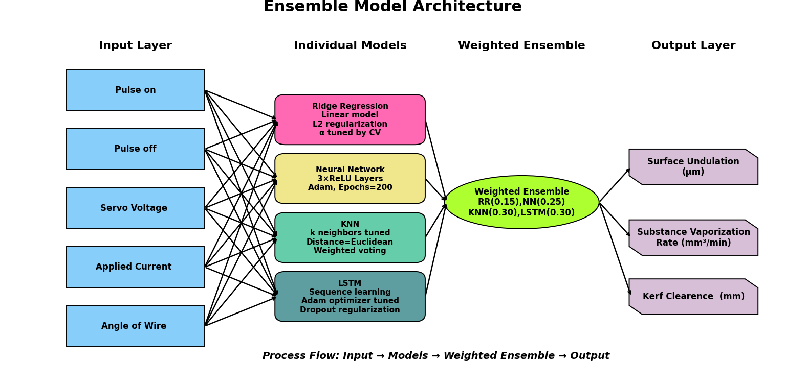

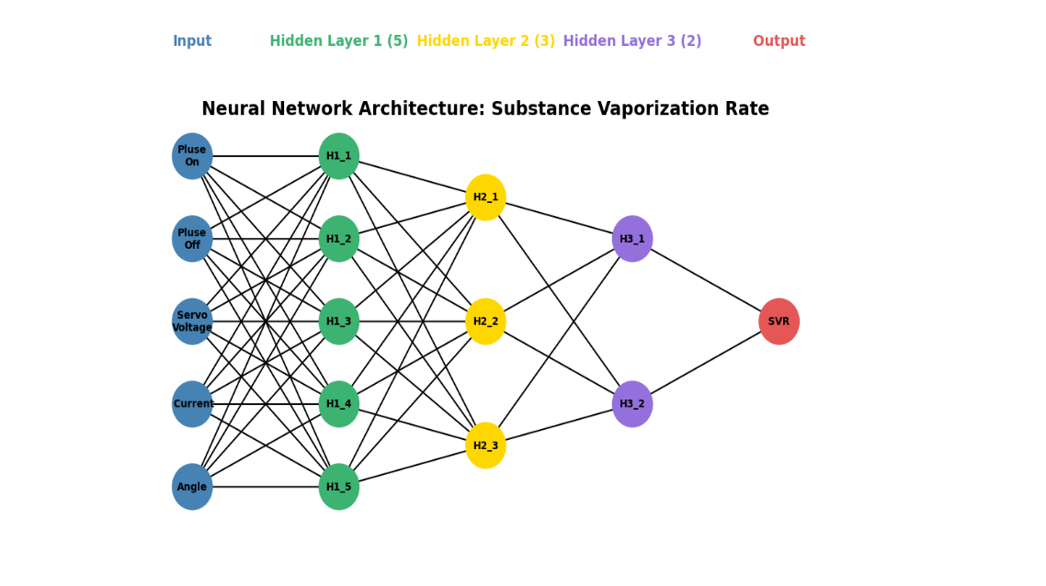
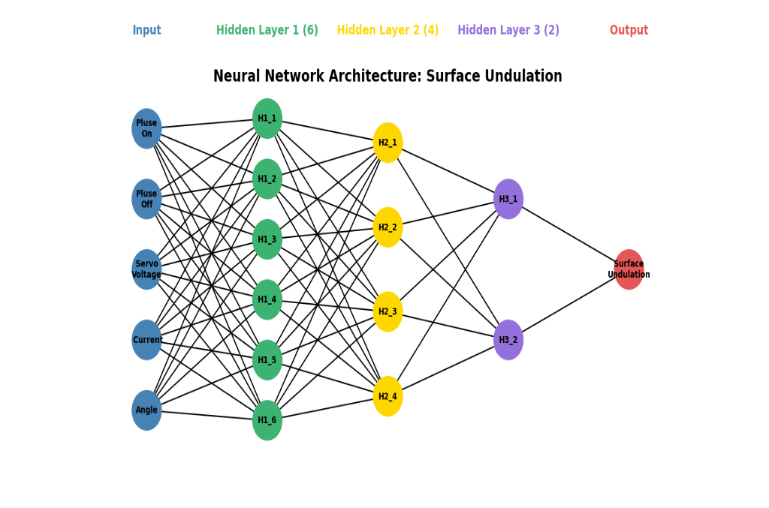

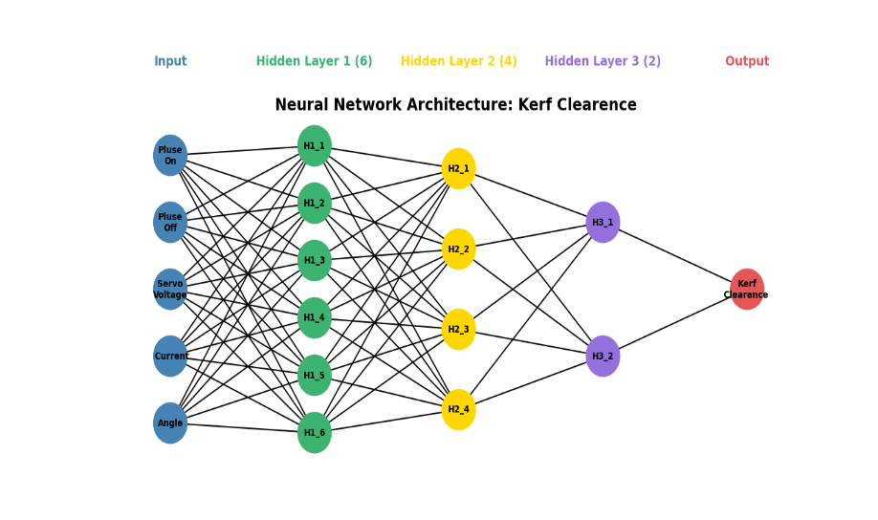

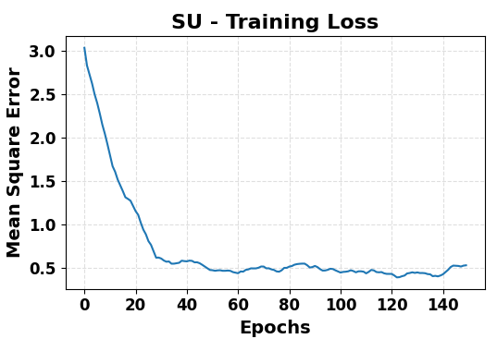
Surface Undulation
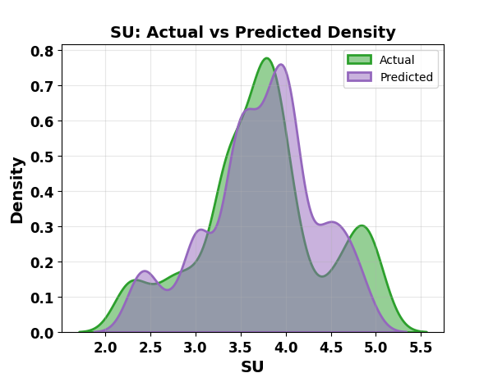
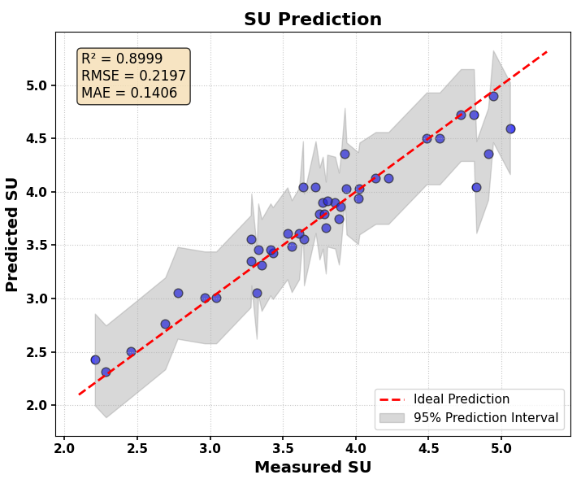
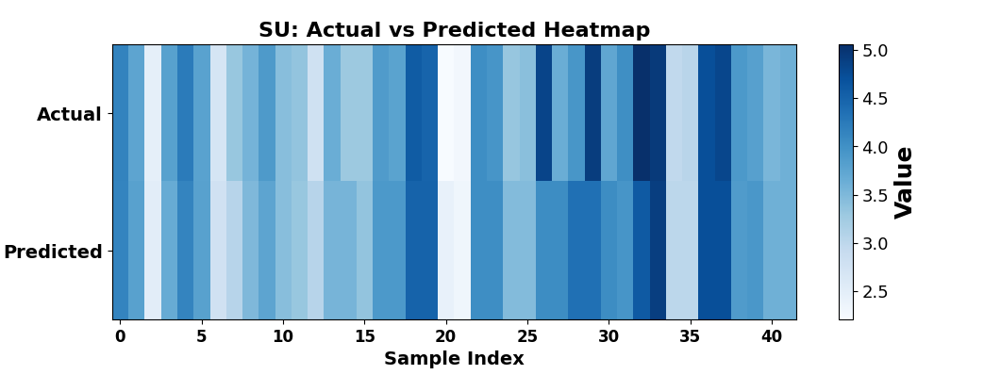
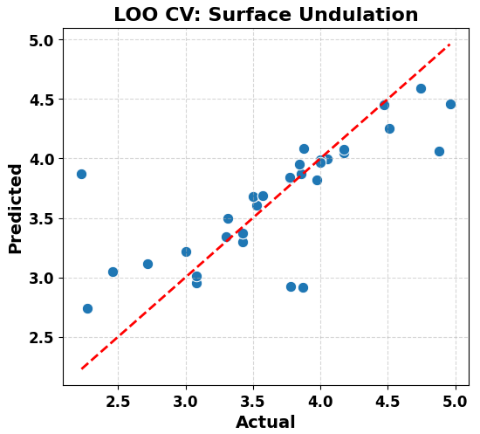
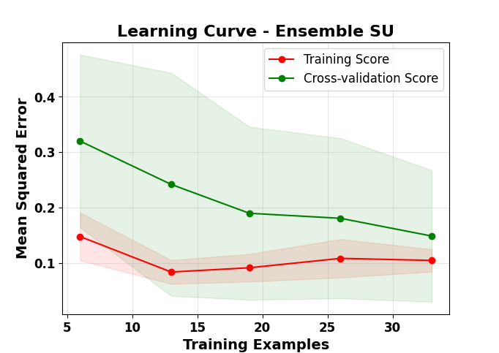

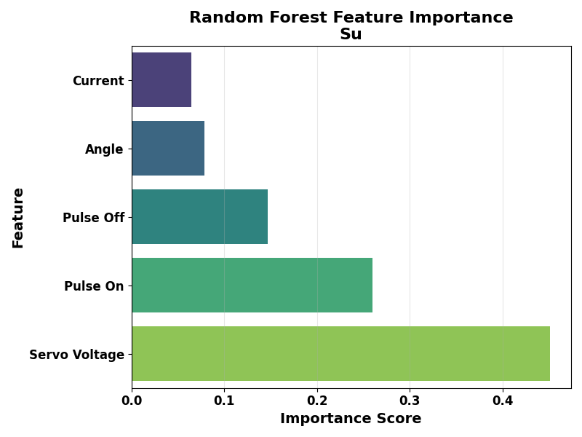
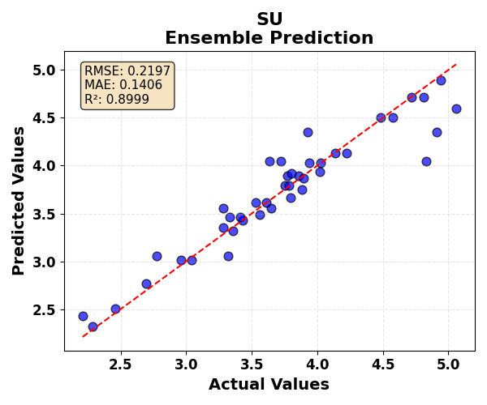
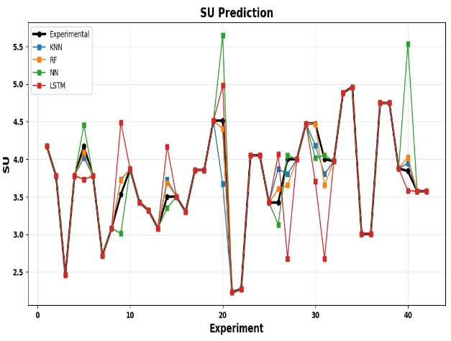

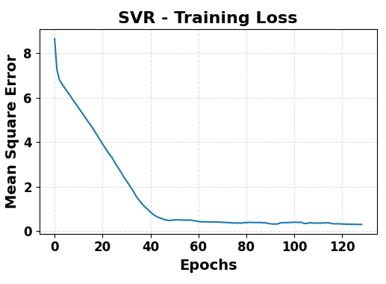
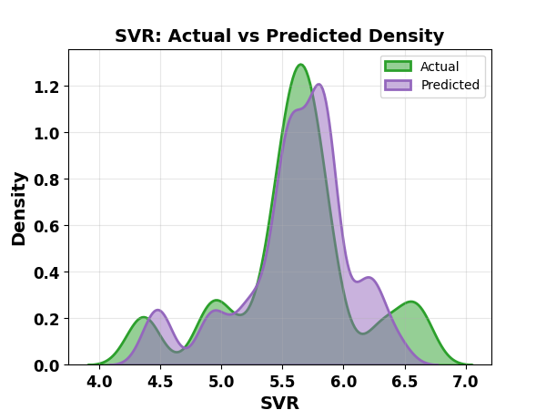
SVR

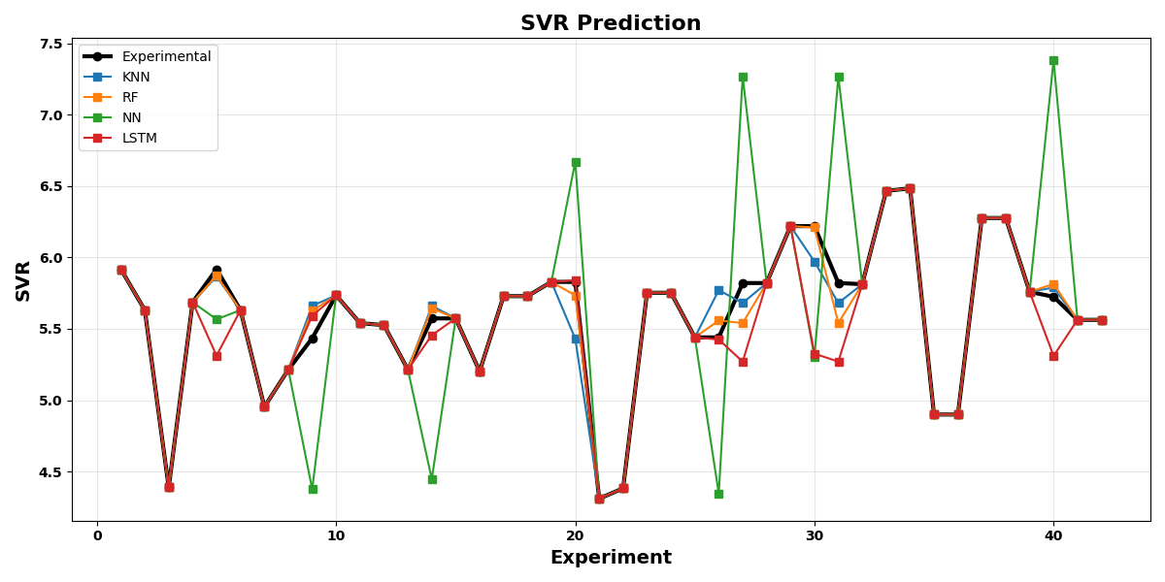
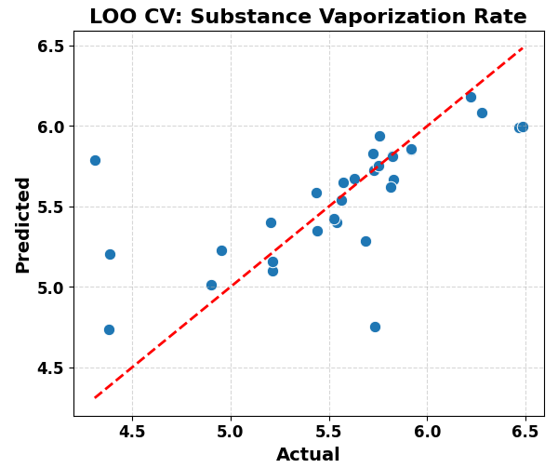
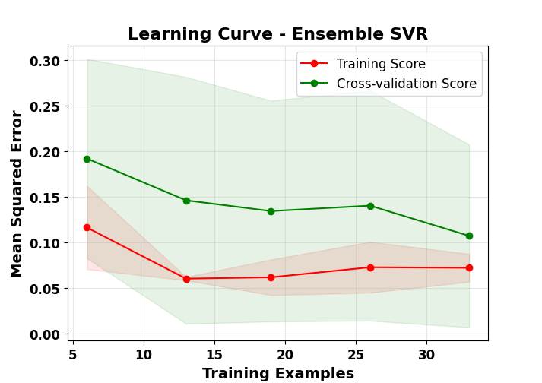
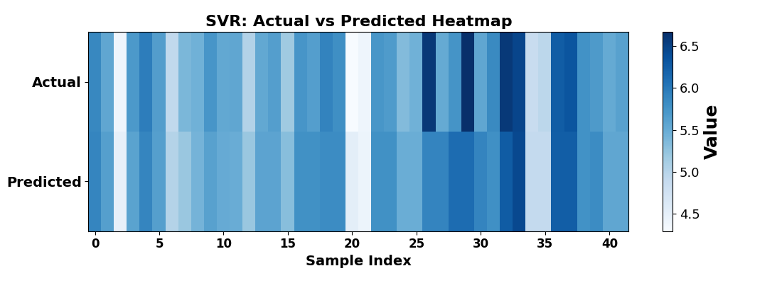

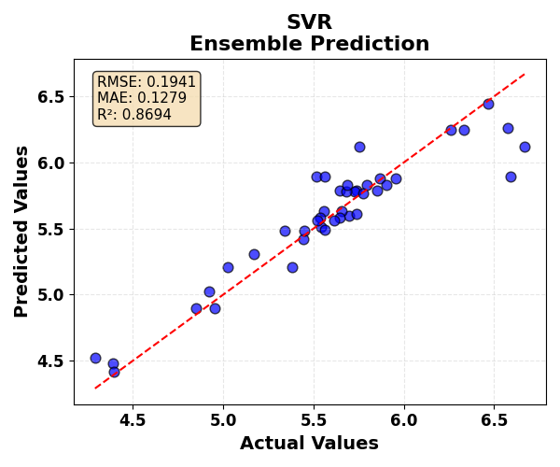

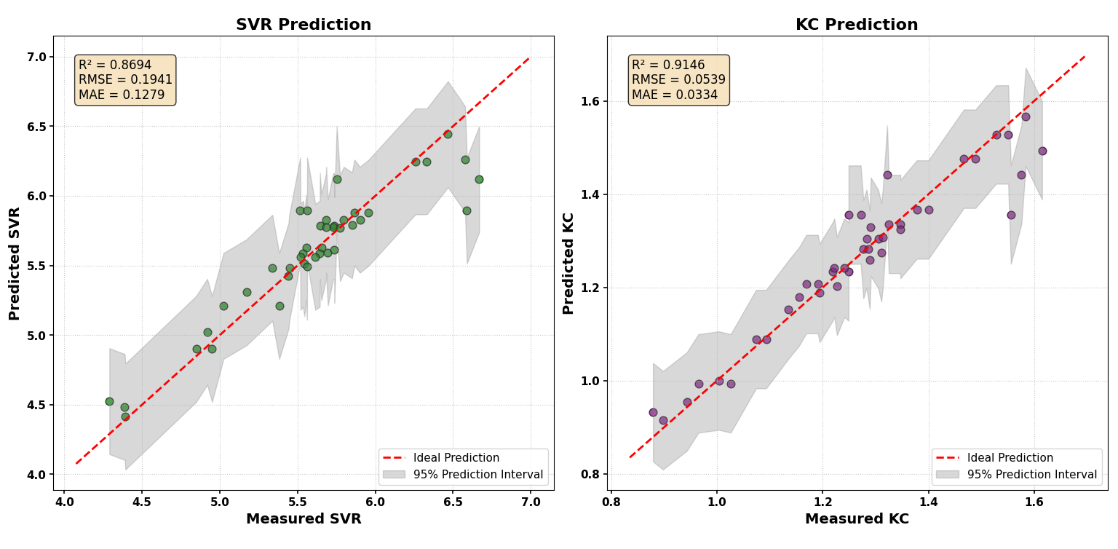
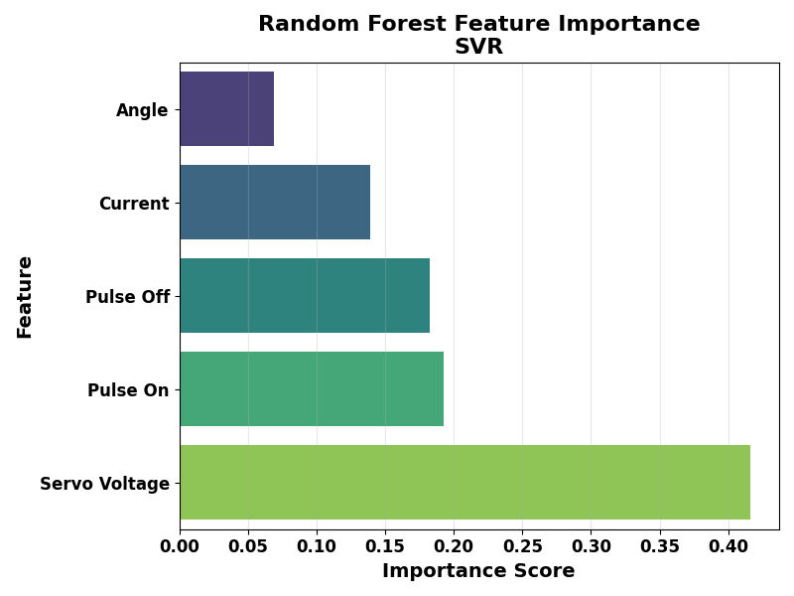

.
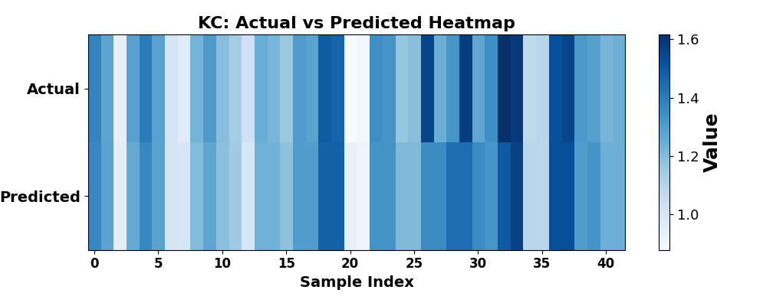
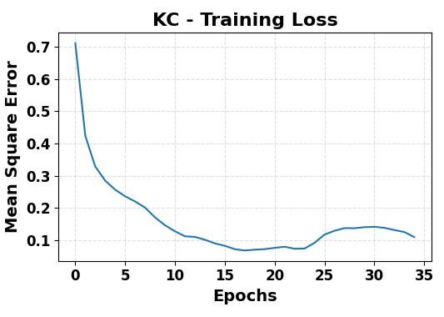
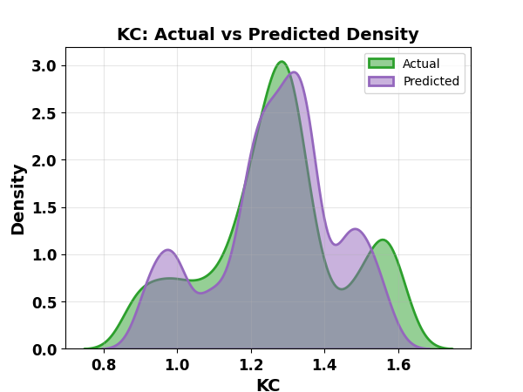
KC


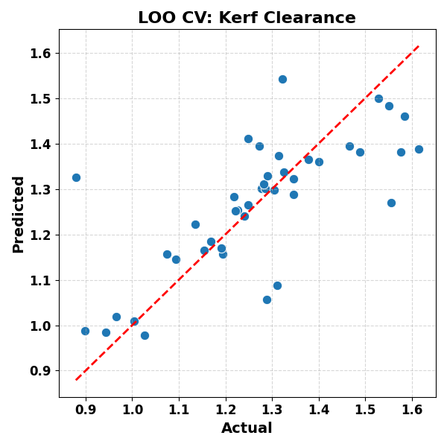
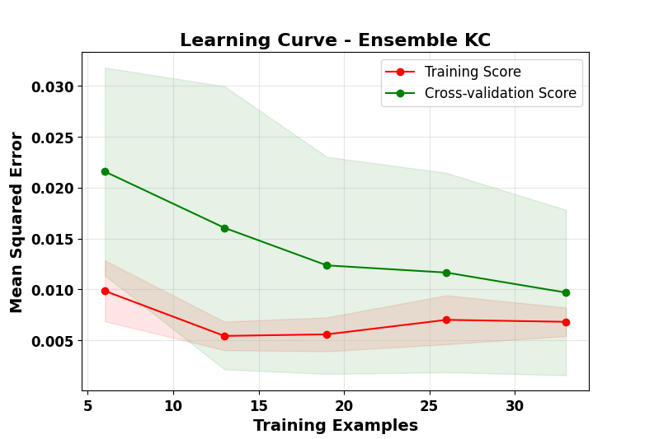

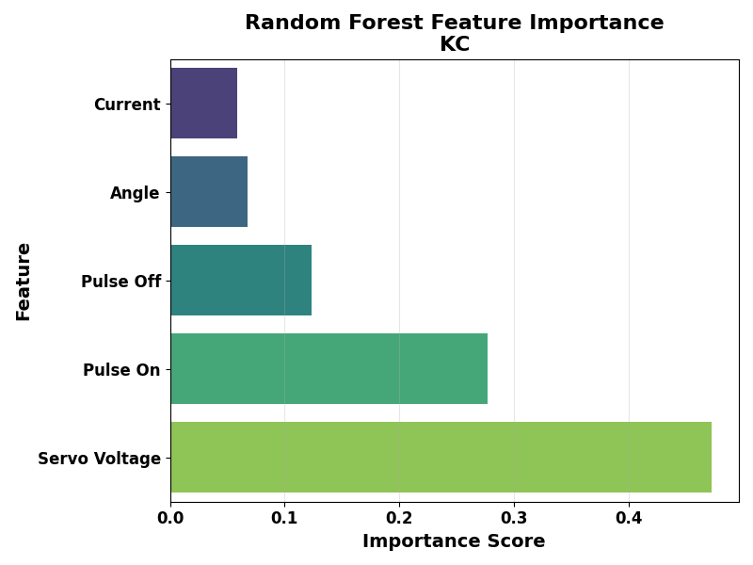
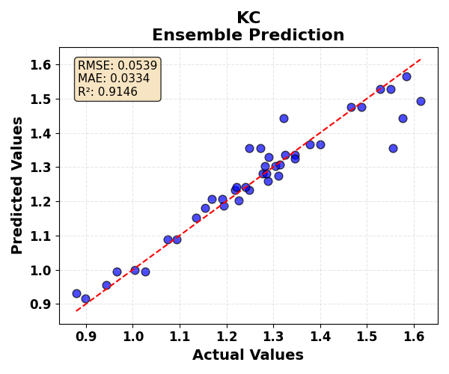
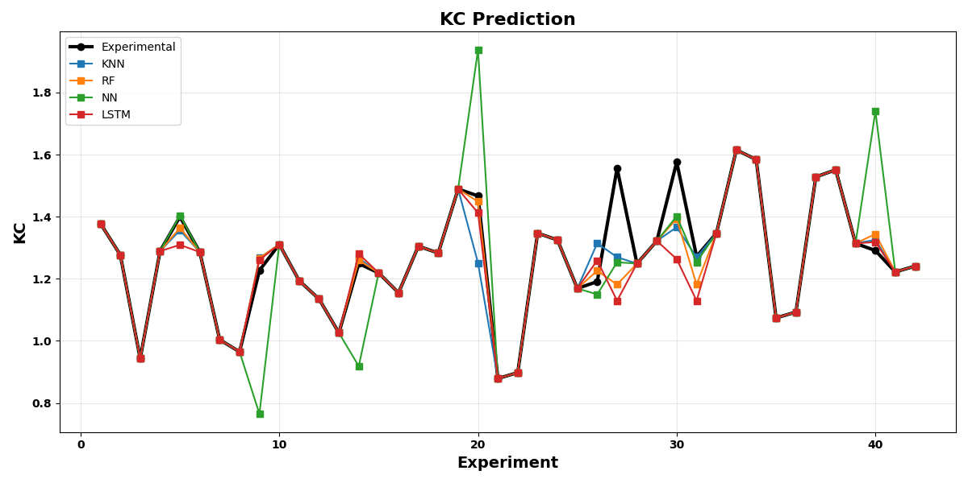

Ensemble Performance Metrics
Target | RMSE | MAE | R²
SU | 0.2197 | 0.1406 | 0.8999
SVR | 0.1941 | 0.1279 | 0.8694
KC | 0.0539 | 0.0334 | 0.9146

HYPERPARAMETER
Output | KNN Hyperparameter | KNN R² | RF Hyperparameter | RF R² | NN Hyperparameter | NN R² | LSTM Hyperparameter | LSTM R²
SU | n_neighbors = 2, metric = Minkowski (p = 2), weights = uniform | 0.934 | n_estimators=300, max_depth=10, max_features='sqrt' | 0.947 | hidden_layers=(6,4,2), learning_rate_init=0.01, activation='relu' | 0.958 | {'LSTM_units': 32, 'Dense_units': 16, 'epochs': 200, 'batch_size': 8, 'optimizer': 'adam'} | 0.963
SVR | n_neighbors = 2, metric = Minkowski (p = 2), weights = uniform | 0.924 | n_estimators=300, max_depth=10, max_features='sqrt' | 0.931 | hidden_layers=(5,3,2), learning_rate_init=0.01, activation='relu' | 0.948 | {'LSTM_units': 32, 'Dense_units': 16, 'epochs': 200, 'batch_size': 8, 'optimizer': 'adam'} | 0.957
KC | n_neighbors = 2, metric = Minkowski (p = 2), weights = uniform | 0.884 | n_estimators=300, max_depth=10, max_features='sqrt' | 0.888 | hidden_layers=(6,4,2), learning_rate_init=0.01, activation='relu' | 0.821 | {'LSTM_units': 32, 'Dense_units': 16, 'epochs': 200, 'batch_size': 8, 'optimizer': 'adam'} | 0.895
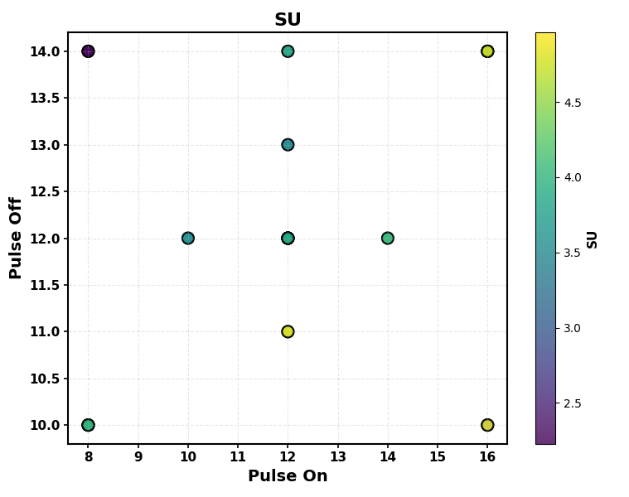

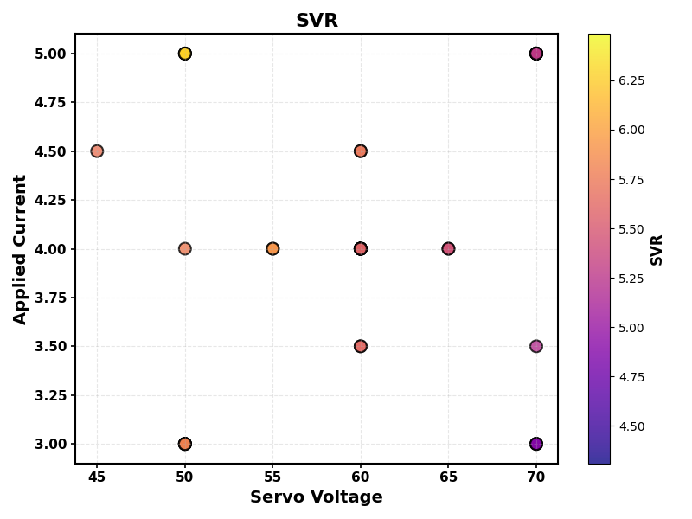

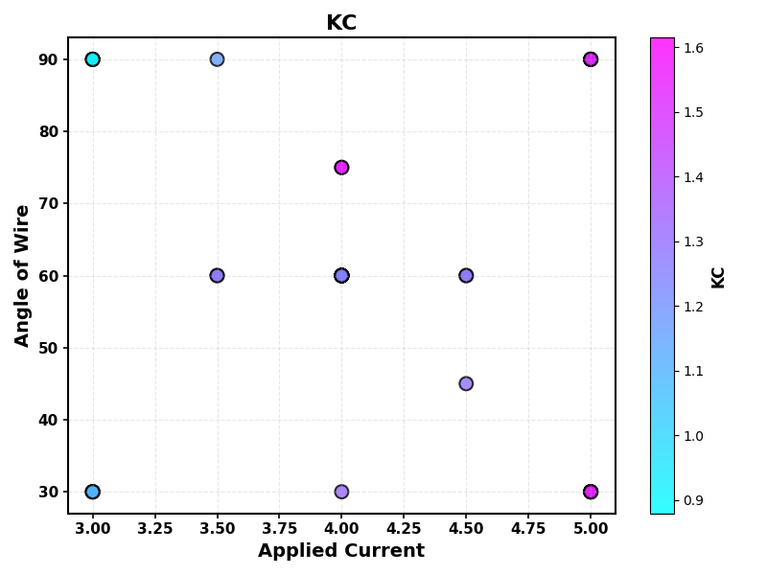

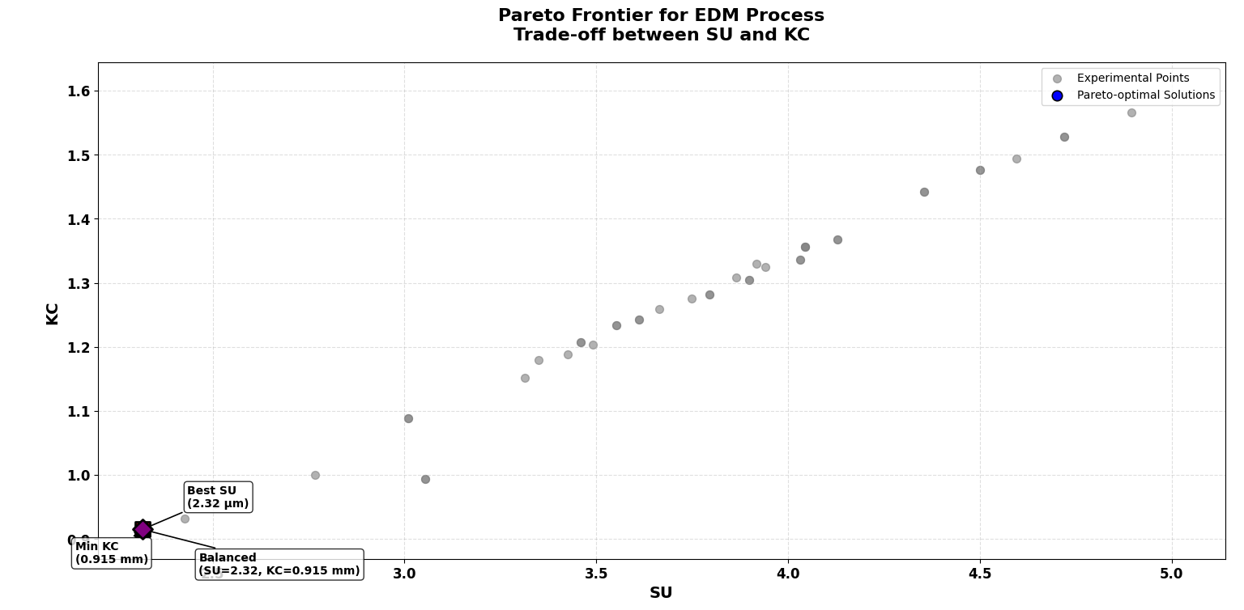

Parameter | Best Quality (Min SU) | Min KC (mm) | Balanced
Pulse On (µs) | 8.000 | 8.000 | 8.000
Pulse Off (µs) | 14.000 | 14.000 | 14.000
Servo Voltage (V) | 70.000 | 70.000 | 70.000
Current (A) | 3.000 | 3.000 | 3.000
Angle (°) | 90.000 | 90.000 | 90.000
SU (µm) | 2.317 | 2.317 | 2.317
KC (mm) | 0.915 | 0.915 | 0.915

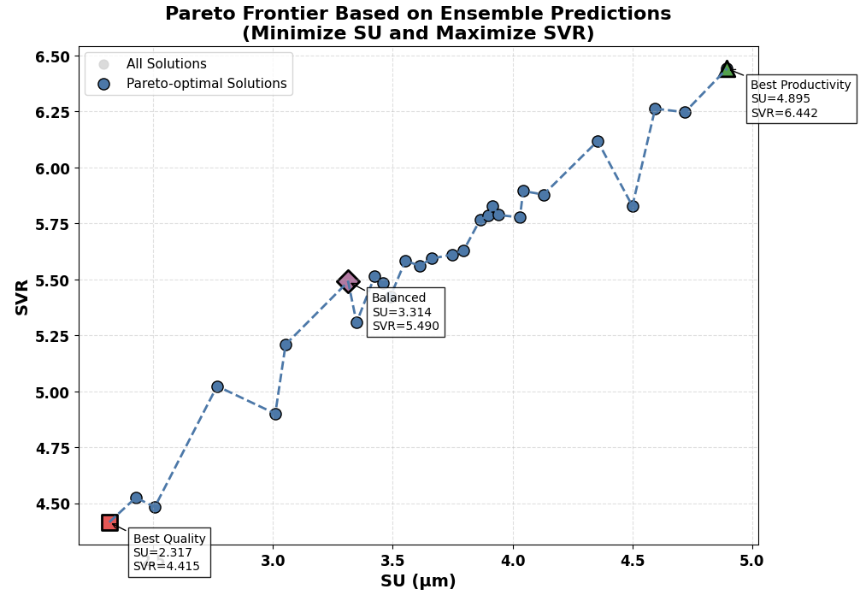

Parameter | Best Quality (Min SU) | Best Productivity (Max SVR) | Balanced
Pulse On (µs) | 8.000 | 16.000 | 16.000
Pulse Off (µs) | 14.000 | 10.000 | 10.000
Servo Voltage (V) | 70.000 | 50.000 | 70.000
Current (A) | 3.000 | 5.000 | 5.000
Angle (°) | 90.000 | 90.000 | 90.000
SU (µm) | 2.317 | 4.895 | 3.314
SVR (mm³/min) | 4.415 | 6.442 | 5.490

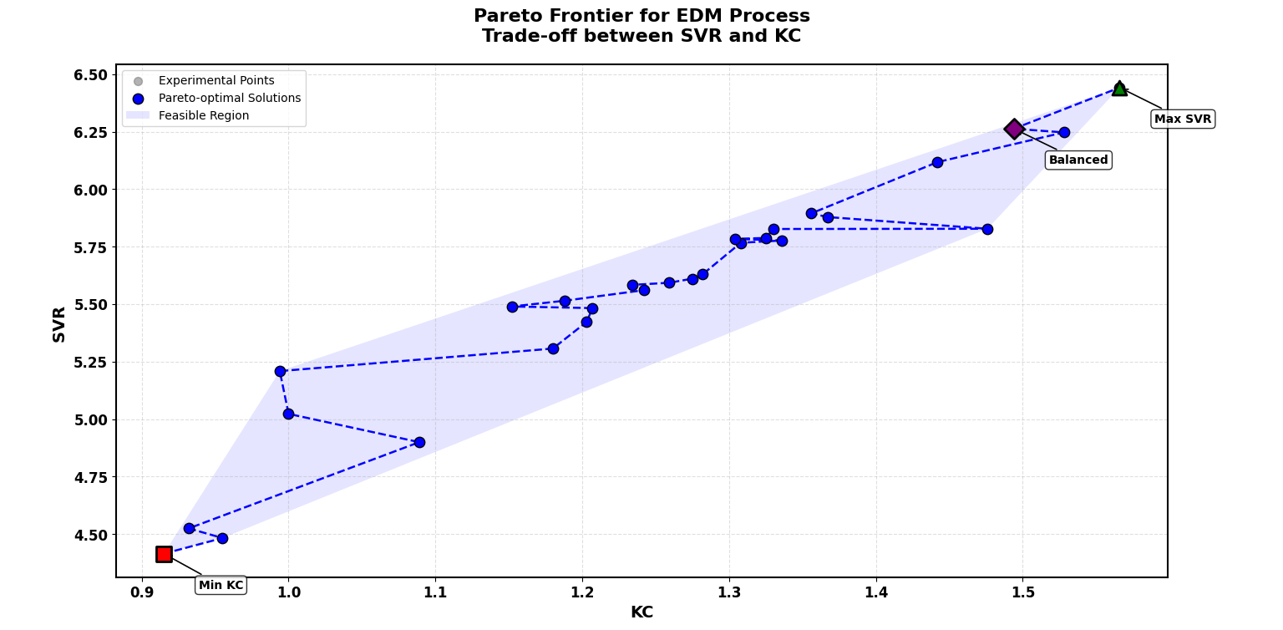

Parameter | Min KC | Max SVR | Balanced
Pulse On (µs) | 8.000 | 16.000 | 12.000
Pulse Off (µs) | 14.000 | 10.000 | 11.000
Servo Voltage (V) | 70.000 | 50.000 | 60.000
Current (A) | 3.000 | 5.000 | 4.000
Angle (°) | 90.000 | 90.000 | 60.000
KC (mm) | 0.915 | 1.566 | 1.494
SVR (mm³/min) | 4.415 | 6.442 | 6.263

